Registry Exception Markup
Review case: LOT-C / TX-771903. Exact extracted source view retained before the analyst attention layer.
Source view — retained without resampling or annotation.
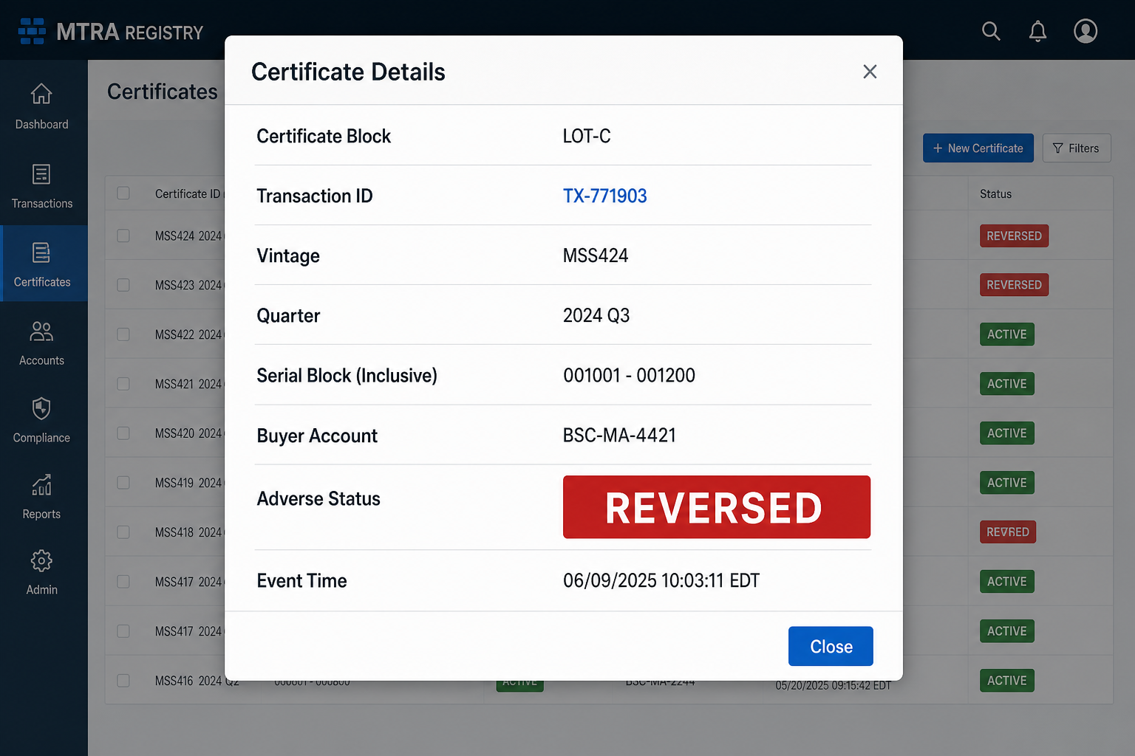
Analyst attention layer — compare against the immediately preceding source view.
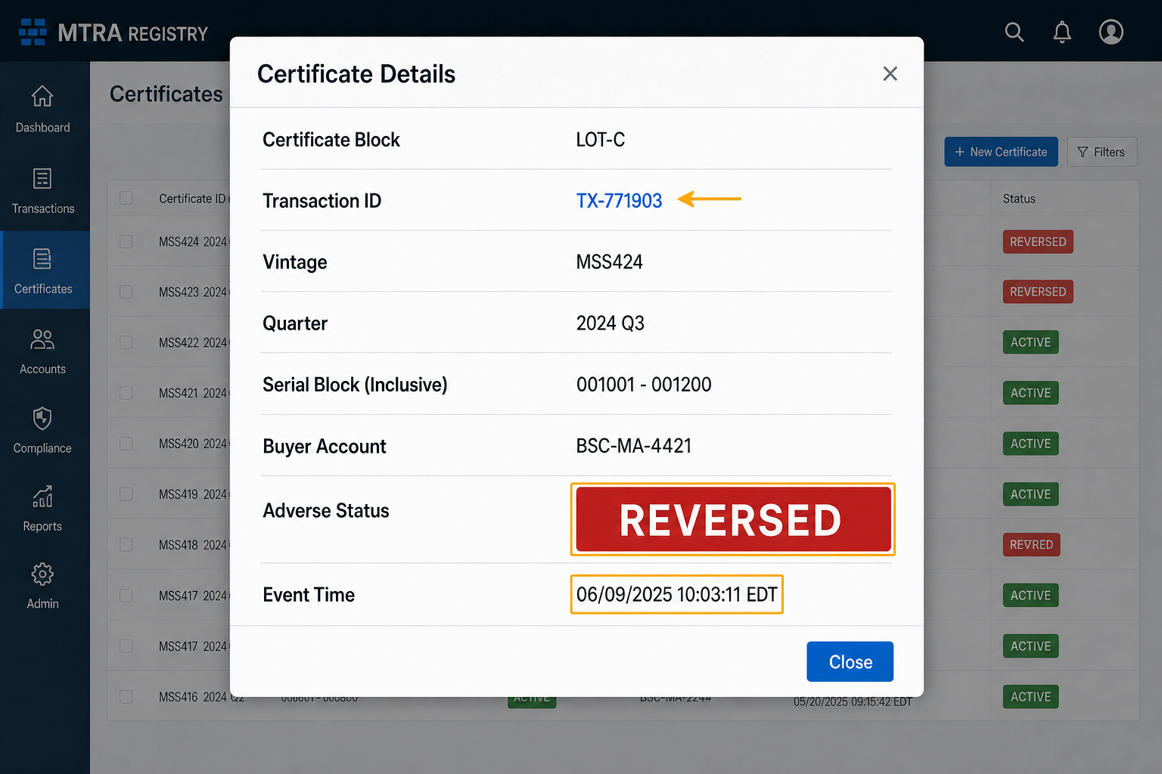
Review cases: LOT-A and REPL-C. Exact extracted source view retained before the analyst attention layer.
Source view — retained without resampling or annotation.
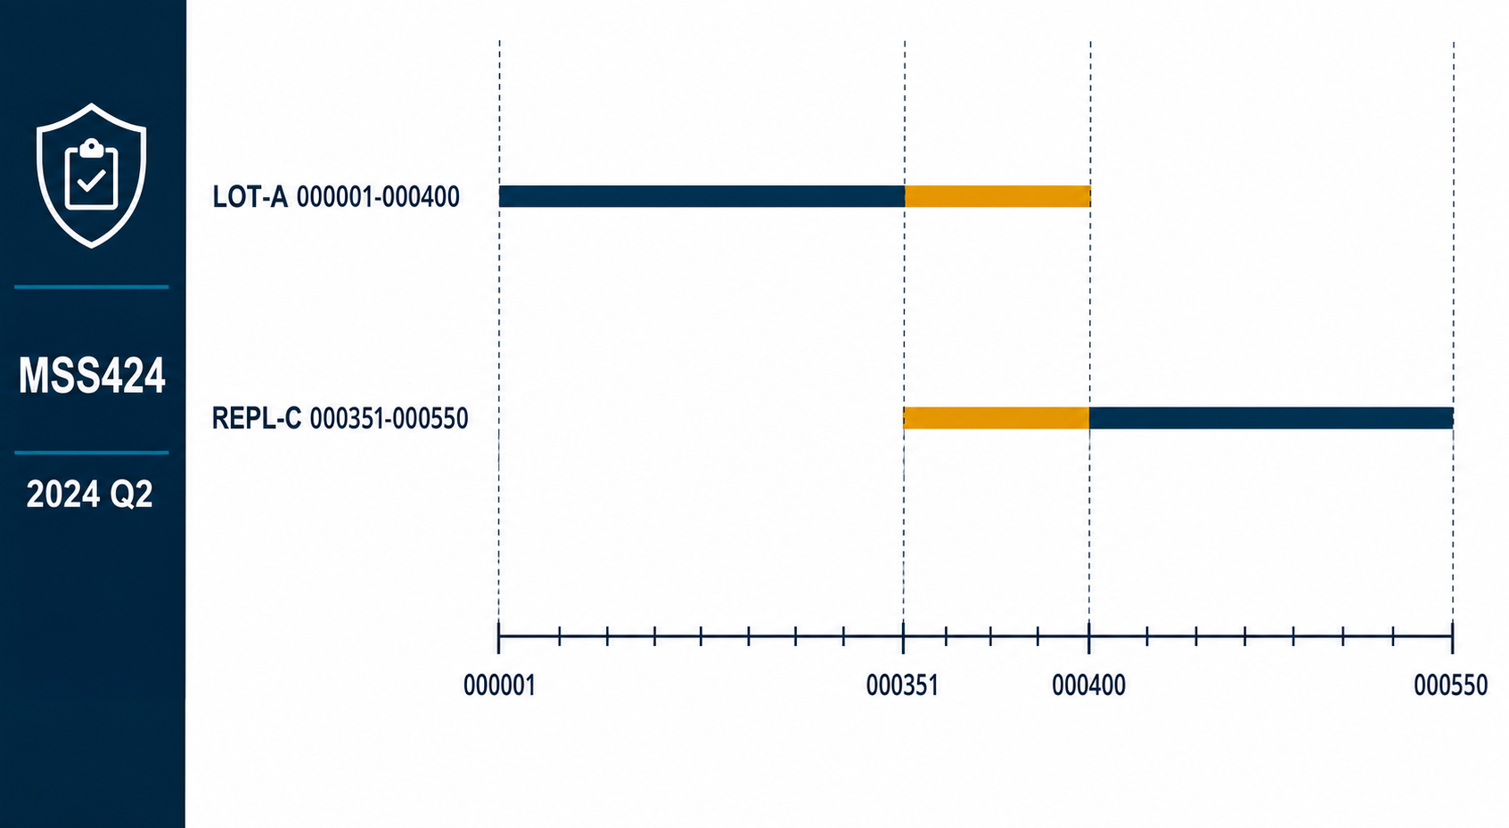
Analyst attention layer — compare against the immediately preceding source view.
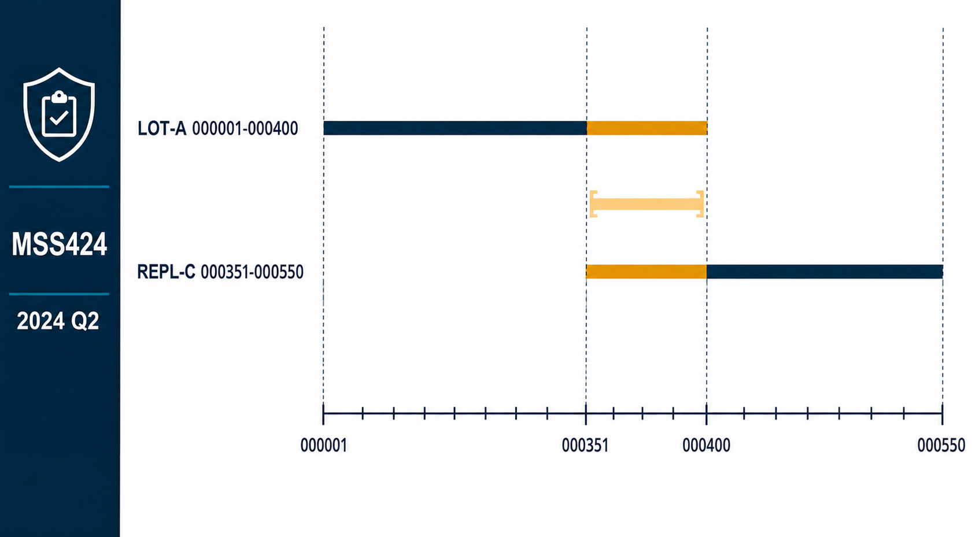
Markup review remains pending supervisory sign-off; this document does not state lot dispositions or settlement totals.

